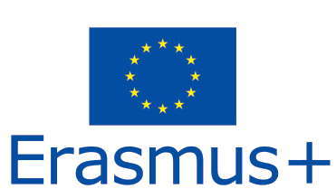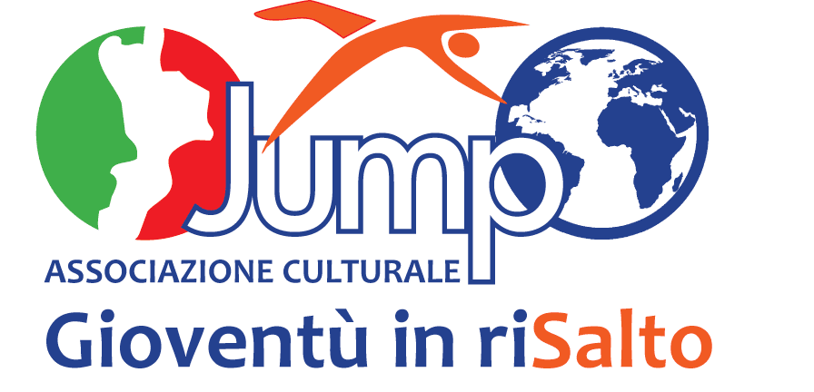

Associazione Culturale Jump – Gioventù in riSalto Via San Nicola, 15 – 88068 Soverato (CZ)

C.F.97073510790 Tel. 0039 3477125632

mail: info@associazionejump.it

JUMP Gioventù in riSalto

PIF 2019 - Partner Identification Form

|  |  |  |  |  |  |  |  |  |  |  |  |
| --- | --- | --- | --- | --- | --- | --- | --- | --- | --- | --- | --- |
| **Partner organisation** | | | | | | | | | | | |
| PIC | **937306636** | | | | | | | | | | |
|  |  |  |  |  |  |  |  |  |  |  |  |
| Full legal name (National Language) | JUMP Gioventù in RiSalto | | | | | | | | | | |
|  |  |  |  |  |  |  |  |  |  |  |  |
| Full legal name (Latin characters) | JUMP Start up youth! | | | | | | | | | | |
|  |  |  |  |  |  |  |  |  |  |  |  |
| Acronym | JUMP | | | | | | | | | | |
|  |  |  |  |  |  |  |  |  |  |  |  |
| National ID (if applicable) |  | | | | | | | | | | |
|  |  |  |  |  |  |  |  |  |  |  |  |
| Department (if applicable) | International area | | | | | | | | | | |
|  |  |  |  |  |  |  |  |  |  |  |  |
| Address | Strada San Nicola 15 | | | | | | | | | | |
|  |  |  |  |  |  |  |  |  |  |  |  |
| Country | Italy | | | | | | | | | | |
|  |  |  |  |  |  |  |  |  |  |  |  |
| Region | Calabria | | | | | | | | | | |
|  |  |  |  |  |  |  |  |  |  |  |  |
| P.O. Box |  | | | | | | | | | | |
|  |  |  |  |  |  |  |  |  |  |  |  |
| Post code | 88068 | | | | | | | | | | |
|  |  |  |  |  |  |  |  |  |  |  |  |
| CEDEX (only for France) |  | | | | | | | | | | |
|  |  |  |  |  |  |  |  |  |  |  |  |
| City | Soverato | | | | | | | | | | |
|  |  |  |  |  |  |  |  |  |  |  |  |
| Website | www.associazionejump.it | | | | | | | | | | |
|  |  |  |  |  |  |  |  |  |  |  |  |
| Email | associazionejump@gmail.com | | | | | | | | | | |
|  |  |  |  |  |  |  |  |  |  |  |  |
| Telephone 1 | 0039 3391964454 | | | | | | | | | | |
|  |  |  |  |  |  |  |  |  |  |  |  |
| Telephone 2 | 0039 3477521632 | | | | | | | | | | |
|  |  |  |  |  |  |  |  |  |  |  |  |
| Fax | no | | | | | | | | | | |
|  |  |  |  |  |  |  |  |  |  |  |  |
|  |  |  |  |  |  |  |  |  |  |  |  |
| **Profile** | | | | | | | | | | | |
|  | |  |  |  |  |  |  |  |  |  |  |
| Type of organization | Cultural association | | | | | | | | | | |
|  |  |  |  |  |  |  |  |  |  |  |  |
| Is the partner organization a public body? | no | | | | | | | | | | |
|  |  |  |  |  |  |  |  |  |  |  |  |
| Is the partner organization a non-profit? | yes | | | | | | | | | | |
|  |  |  |  |  |  |  |  |  |  |  |  |
| Number of staff:  Number of learners: | 12  210 |  |  |  |  |  |  |  |  |  |  |
|  |  |  |  |  |  |  |  |  |  |  |  |
|  |  |  |  |  |  |  |  |  |  |  |  |
|  |  |  |  |  |  |  |  |  |  |  |  |
|  |  |  |  |  |  |  |  |  |  |  |  |
| **Background and experience** | | | | | | | | | | | |
| *Our full organisation profile* | | | | | | | | | | | |
| JUMP is a cultural association which was born precisely in the « deep deep South » of Italy with the specific mission to bring Europe and internationalization in Calabria region, especially in the province of Catanzaro characterised by the lack of services and opportunities.  Our name, “JUMP” expresses our will to "play up" local and international resources, creative thinking and passion into action. The word “Gioventù” means “Youth” but we are not properly just a «youth organisation», we are team of experts and competent young adults and «Youth» refers to the “Youth spirit” which is inside us and sustain all our work. We strongly believe in the active ageing and in the lifelong learning for all which can be enriched and fostered thanks to European projects where people from different Countries cooperate and meet.  JUMP is leader and partner of several Erasmus projects. Watch our website continuously updated.  Referring to the K1 (mobility for individuals), the organisation acts as training provider for teachers, school directors and adults in general. Since 2015 JUMP realised more than 70 structured trainings, job placement project, job shadowing and other types international programs.  More than 210 persons came in Soverato to attend one of our trainings.  The team of trainers is composed by 15 young adults with international experience, motivation and a strong passion in training young people and other adults.  Due to the difficult and sad situations in Europe and in the world, the crisis of “youth spirit” is transforming young people in being sceptical, worried and pessimistic. The same is happening to adult people who lost hope in the present, affected by less salaries, political instability and terrorism, furthermore, families are preoccupied for the future of young generations.  JUMPS works day by day, developing small and large scale actions to face these real situations, finding answers and opportunities.  The main powerful tool we have is “Education and lifelong learning”.  According to the new aims of the EU 2020 Strategy and answering to a specific need of the actual society to fight unemployment, especially youth unemployment and the economical crisis, since 2014 JUMP started to focus on 3 main sectors:  TRAINING, INFORMATION AND EUROPEAN PROJECT DESIGN&MANAGEMENT.  In 2015 JUMP started a new process in the field of - "entrepreneurship education and development of the culture of entrepreneurship" through different actions:  - access to finance and to European funds through specific training courses on European Project Design and Management (EPCM);  - internationalization of local business and development of creativity and spirit of initiative among youth, young entrepreneurs, School Directors, teachers and also adult people but with a "young spirit";  - raising awareness on European topics organising public events for citizens and stakeholders;  - proposing projects aiming at networking of actors operating in different fields (Transectorial) promoting exchange of practices, competences and cross-cultural growing, especially in the South of Italy. | | | | | | | | | | | |
| JUMP is now a competent team of experts able to run international projects, to develop training pathways, bring innovation and transfer innovation to have a local and global impact. JUMP works also to mainstream results and foster a dynamic dialogue with decision makers in order to change policies or take part to public debates at political level.  Main activities are:   * organization of international trainings on different topics for teachers, school directors, educators, managers and adults in general. At the moment the catalogue consists on 16 training proposals published on http://www.associazionejump.it/ * development of European policies through European projects involving transectorial actors from civil society and public institutions * contact making meetings for managers and leaders for Partnership Building and to start up future cooperations * mobility projects for educators and youth, sending organization for youth trainings, seminars, youth events, youth exchanges and EVS volunteers * hosting projects for EVS volunteers and traineeships with Erasmus Plus, Entrepreneurs with the Erasmus for Young Entrepreneurs Programme (EYE Program) * local development and internationalization for public administration and local authorities * organization of public events to foster and promote European citizens and debates on EU priorities and actuality (3 Editions of the Euro.Soul Festival. European soul) * placement of students and teachers by local partners (companies, commercial studios, insurance, institutions, entrepreneurs, medical services, social assistance services etc) make traineeships, learning or working experiences * Least but not last, active simple local volunteering involving citizens and taking part to grassroots events, raising attention to local issues and problems, finding solutions, making things informally and being conscious on global criticalities. | | | | | | | | | | | |
| **Our method: the “B.E.S.T”** | | | | | | | | | | | |
| JUMP bases its work on a method which we call, *"B.E.S.T. Method" - Building Europe in a Small Town* which means something simple but not easy to put into action, especially in the South of Italy.  The context of Catanzaro, in general of Calabria region needs time to understand and acquire the processes of social cohesion recommended by European guidelines.  Our method is to make international something that is local and valorise the local through the development of a long term process of internationalisation made of small steps. It’s an internal policy of JUMP: develop innovative trainings, programs for international guests with locals aiming at discovering cultures and traditions of the South and, at the same time, open people’s mind and train all actors in being part of a European community.  JUMP is training provider of the Erasmus Plus program and develops different kind of projects creating continuously opportunities for all to learn, discover and widen perspectives, empowering soft and hard skills useful for the actual society.  Since 2017 JUMP renewed and changed skin thanks to a new website which shows better also training proposals and initiatives for locals. Every time that the organisation hosts a group of teachers, or professionals or students from other countries, immediately we call partners and members to enrich hosting programs in Soverato and benefit people who are training themselves and want to gain more international experience, speak English and improve soft skills. JUMP adopted the strategy to bring "international guests" in the local context and it's a long term process which needs an important approach with local services, structures and people. It's bringing here Europe that we internationalise.  Have a look to our website, explore the photo galleries and the video-gallery in the homepage, read the page “Our method” and you will understand much better the atmosphere we like to create. | | | | | | | | | | | |
| **What are the skills and expertise of key staff/persons involved in this application?** | |  |  |  |  |  |  |  |  |  |  |
| JUMP is now a competent team of experts able to run international projects, to develop training proposals, bring innovation and transfer innovation to have a local and global impact. JUMP works also to mainstream results and foster a dynamic dialogue with decision makers in order to change policies or take part to public debates at political level. Here below the profiles of the 2 coordinators but, please, always think about JUMP as a team. Their description of their professional background is published on the website <http://www.associazionejump.it/>  Pietro Curatola  Graduated at Modena University in business economics then he has been working 16 years in Emilia Romagna in the field of finance and credit. In 2012 he decided to come back to Soverato aware that, with the competences and experience gained, could be useful for the territory. Pietro also lived a period in London learning English and working at the same time. In 2012 he founded JUMP Gioventù in riSalto and started to train himself in the field of Project Design and Management, applying for grants and monitoring EU funding programs, upgrading himself and making networking. In 2013 - 2014 JUMP was soon awarded with the first projects and it started a period of intensive activities, trainings and mobilities in Italy and abroad. Pietro Curatola the president, graduated in Economy and marketing, has been working 16 years in Modena in the field of finance and credit then decided to come back to Calabria region, in Soverato where he is working to contribute to help the territory to raise up from the social and economical crisis. Pietro brought his competences acquired along the years and trained himself in project management and European funds. Starting with JUMP he decided to promote the third sector and the empowerment of young people in society. From 2015 is leader of the C.T.E. another reality which is going to be a start up targeted to young and new entrepreneurs of the South bringing internationalization in the territory through innovative events, trainings and information.  Erika Gerardini  Graduated in foreign languages and international communication at Parma University, Erika started soon to work in the field of International youth mobility and European projects in Rome during the civil service by AFSAI, Associazione per la Formazione e gli Scambi Culturali. One of the main important working experience has been afterwards by the FNG Forum Nazionale Giovani for 3 years as international officer, project designer and manager. In 2008 Erika founded with a close group of friends AIM Agency for Interculture and Mobility in Rome which in 2009 was awarded by a long term contract by the Italian Representation of the European Commission in Italy. In 2010 Erika started to work inside the secretary's office of the Spazio Europa, the European Public Space. From 2010 to 2014 worked at different level organizing trainings, as trainer herself, implemented granted project and always creating new sinergies and ideas to apply for call for proposals. In 2014 she met Pietro in Rome and for love she left the "eternal capital" moving to Soverato with the same aim of be an active player at local level and bring social innovation. She coordinates JUMP with Pietro and the staff and implements projects, trainings, events and educational activities for youth, teachers and for the whole community. | | | | | | | | | | | |
|  |  |  |  |  |  |  |  |  |  |  |  |
| **Contact person** | | | | | | | | | | | |
|  | |  |  |  |  |  |  |  |  |  |  |
| Title | Mrs | | | | | | | | | | |
|  |  |  |  |  |  |  |  |  |  |  |  |
| Gender | Female | | | | | | | | | | |
|  |  |  |  |  |  |  |  |  |  |  |  |
| First name | Erika | | | | | | | | | | |
|  |  |  |  |  |  |  |  |  |  |  |  |
| Family name | Gerardini | | | | | | | | | | |
|  |  |  |  |  |  |  |  |  |  |  |  |
| Department | European Project Management | | | | | | | | | | |
|  |  |  |  |  |  |  |  |  |  |  |  |
| Position | Responsible of the international department | | | | | | | | | | |
|  |  |  |  |  |  |  |  |  |  |  |  |
| Email | associazionejump@gmail.com | | | | | | | | | | |
|  |  |  |  |  |  |  |  |  |  |  |  |
| Telephone | 0039 3391964454 | | | | | | | | | | |
|  |  |  |  |  |  |  |  |  |  |  |  |