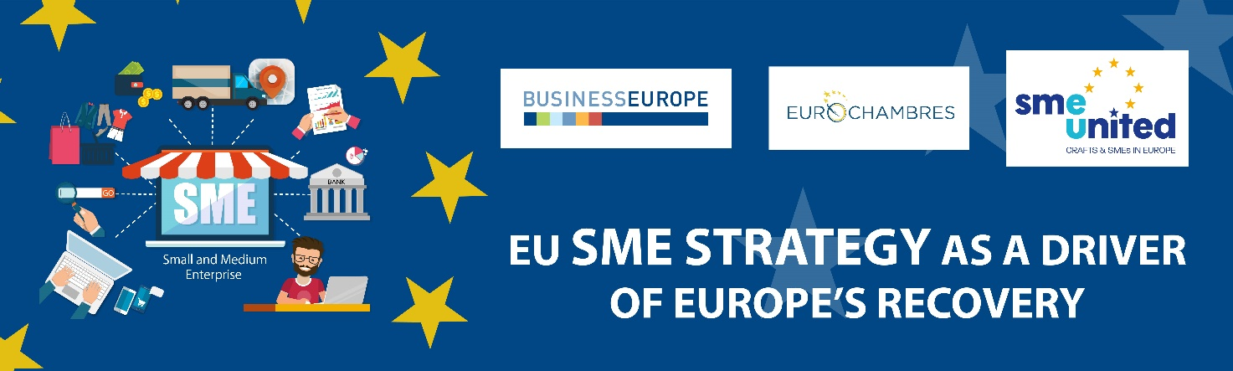

EU SME Strategy as a driver of Europe’s Recovery
23 September 2020
14h00 – 15h30 (Brussels time)

SME-friendly policies are crucial to Europe’s social and economic wellbeing, never more so than now as businesses seek to recover from the damaging impact of COVID-19. This in turn necessitates a comprehensive and robust SME Strategy that reflects the scale of the crisis and engages EU institutions, national governments, and a broad range of stakeholders in providing the millions of small and medium enterprises across Europe with the right conditions to drive the economic revival.

The webinar will be opened by a keynote speech by European Commissioner for Internal Market Thierry Breton and followed by statements by German Federal Minister for Economic Affairs and Energy Peter Altmaier and the Co-Chair of the European Parliament SME Intergroup MEP Martina Dlabajova.

Interventions by EUROCHAMBRES President Christoph Leitl, BusinessEurope Director General Markus J. Beyrer and SMEunited's President Alban Maggiar focusing on the policy areas and actions needed to avoid long-term scars to EU economy will follow.

A Q&A session will close the webinar.

Please register here by 18 September 2020 the latest. Link and instructions will be sent to the confirmed participants after their registration.

Please note that we may take pictures and/or make video and audio recordings at this event, in which you may be featured. By registering to the event, you give the organisers the right to use such material for non-commercial purposes, including the posting of photos and/or videos on our website. An attendance list with your name and the organisation you represent will be prepared.
You can read our privacy policy for further information. Should you no longer wish to receive invitations to events organised by EUROCHAMBRES, please email privacy@eurochambres.eu

